Enhancing Environmental Search Engines
with Information Landscapes
Klaus Tochtermann, Vedran Sabol, Wolfgang Kienreich, Michael Granitzer and Jutta Becker
Abstract
In this paper, we evaluate enhanced search and retrieval concepts for environmental information systems by exploiting the concept of information landscapes. The advantages of information landscapes compared to traditional search engines are manifold: Thematic clusters which exist in the result set are extracted offering users a thematic overview of the topic they are interested in. Multi-dimensional navigation opens up new ways to explore the result set. An explicit comparison of contributions made to the result by different environmental information systems becomes possible, allowing assessments of the relevance of environmental topics in these different systems. Finally, information landscape can take the role of an mediating entity between users and traditional environmental search engines.

Introduction
Environmental information is typically made up of a variety of different data types. Examples include satellite photos, cartographic information, the results of empirical observations, environmental studies and reports etc. In order to provide effective access to this type of information, the majority of environmental information systems provides some sort of metadata, i.e. data describing data (Tochtermann 2002). The metadata mainly serves the purpose to easily find environmental information objects with environmental search engines such as German Environmental Network (GEIN, www.gein.de) or Environmental Data Catalogue (UDK, www.umweltdatenkatalog.de) and to improve the quality of search results.
Such systems share some drawbacks with standard search engines:

- Search engines display the results as a one-dimensional, ranked list of links pointing to the respective environmental information object, thus hiding topical clustering of the result set and denying novices in a field overview information on the topic.

- Users cannot access desired results in one step. Multiple refinement queries based on already obtained but still too unspecific result sets have to be executed to narrow search results down to the intended set of entries, especially if the initial search terms were unspecific and common in nature.

Based on these observations the idea is to capitalize on identified synergies between environmental informatics and visualisation techniques as they are known and successfully applied in knowledge management (Tochtermann et al. 2000). In this context, we present the concept of information landscape and its application to search for environmental information.

Information Landscapes – a new way to explore environmental information repositories
This section presents a new approach of exploring environmental information repositories. Standard environmental search engines, such as GEIN and UDK, expose the content of millions environmental information objects through query interfaces which usually take a lists of two to four keywords and return a one-dimensional result list sorted by relevance. Result lists typically contain thousands of items, as the number of keywords commonly provided is much too small to narrow results down to a manageable amount. Ambiguities between keywords and abbreviations characteristic for the environmental context only worsen this situation. Two observations summarize the problem and point towards a possible solution:
Some query keywords are better than others: Specific to the search space and used engine, some query keywords lead to a much better narrowing of the result set than others. Providing users with a selection of such “power keywords” eases search result refinement and leads to a better understanding of what a given result set is all about.
Relevance cannot be measured in one dimension. Result sets typically cluster around several topics. A (one-dimensional) relevance-sorted result list insufficiently represents this structure. Providing users with distinct clusters of documents dealing with the same topic would allow users to comprehend the result space of a query and to easily refine their initial search.
We apply the concept of visualization islands to overcome these shortcomings of standard search engines. According to Sabol (Sabol 2001), visualization islands is a visualization system based on the principle of information landscapes (Chalmers 1993). The idea of information islands is to visualize results of a search query as a satellite view of an island landscape. Each result item is represented by a small island, with similar items being placed close to each other. Resulting clusters of islands can be identified and labeled using data from the underlying information objects.

Visualising the UDK result sets with the WebRat system
WebRat is a multipurpose retrieval and visualization framework utilizing the information island. (Granitzer et al., 2002). WebRat allows users to formulate queries against any number of configured data sources (i.e. indexing services, web search engines, intranets etc.). Query results are then merged, clustered and visualised with labels describing the most obvious clusters of found documents to allow easy query reformulation and refinement. For use in an environmental context, WebRat has been connected to GEIN and UDK.
Returned results are processed by the system and displayed in a visualisation. Results form islands on a virtual satellite map which are labelled with the according keywords. As figure 3 shows, the concept of the visualization is simple: documents with similar content are placed closer together, and islands appear where there is a concentration of closely related documents. The areas between islands can be interesting because they contain fewer documents but with maybe more unique content.
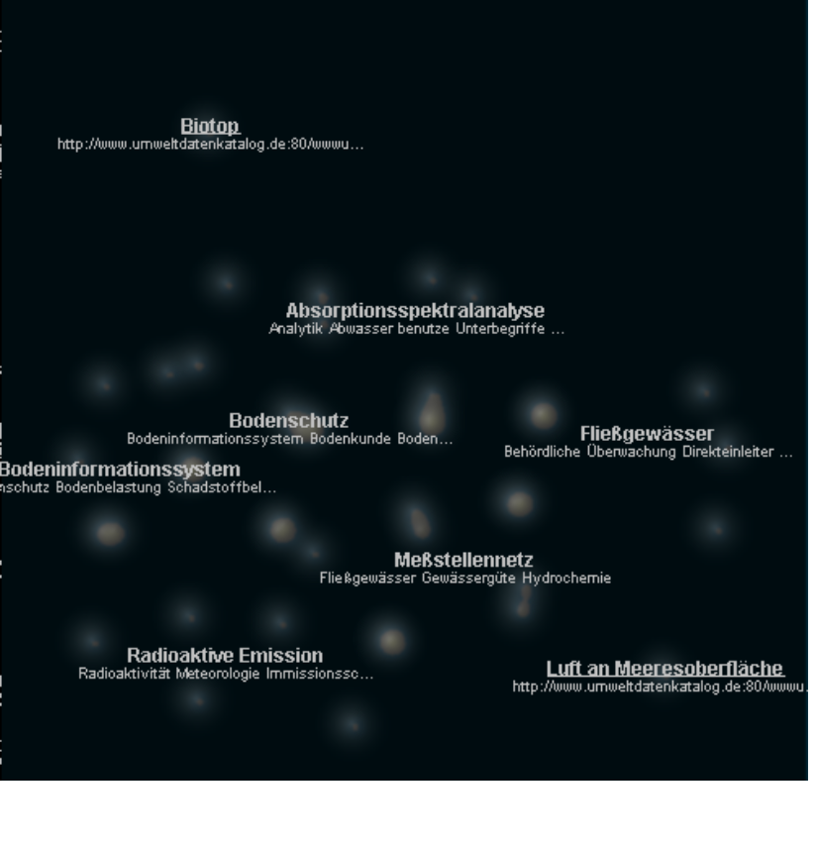
Fig. 1: WebRat displaying results for a query for “Schwermetalle” in UDK,
8 thematic islands (e.g., Meßstellennetz, Fließgewässer) are identified by WebRat
The visualisation is updated “on the fly” as more and more results arrive. Users can zoom in and out on the map, revealing more details or displaying an overview in the process. Labels are also calculated on the fly, accordingly, to always describe the most obvious concentrations of documents (the biggest islands).
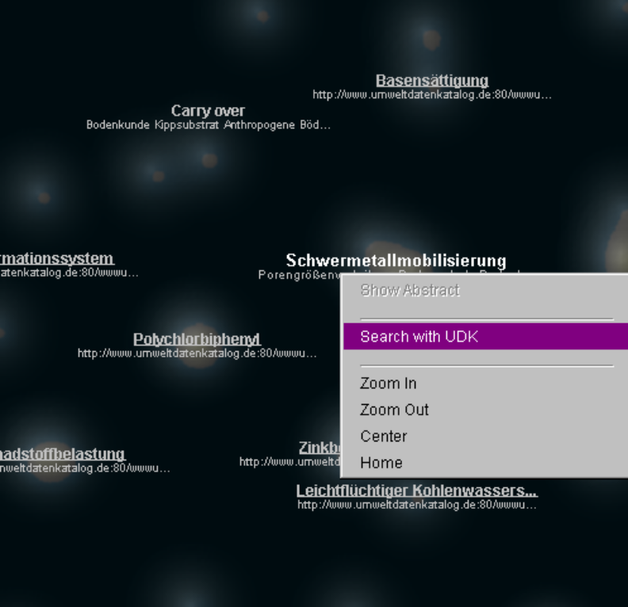For each labelled island, users can call up a context menu using the right mouse button, which allows to explore any of the used repositories by refining the original query with the label keywords of the selected island. This way, users can refine query terms quickly and efficiently. In addition, the context menu contains basic navigational functionality like zoom in, zoom out and “home”, which resets the point of view to display the whole map.

Fig. 2: Zoom of figure 1 showing new information islands

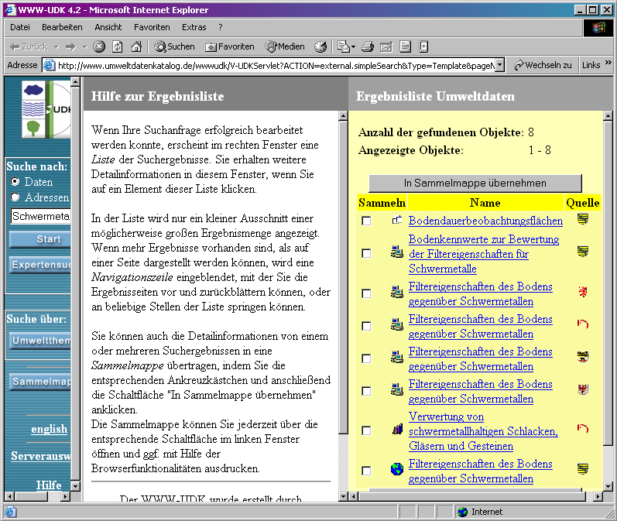
Fig. 3: UDK results refined by keyword selected in figure 2

Information islands to compare different environmental information sources
WebRat can run the aforementioned extraction of topical structures against more than one information source at a time for a given query expression. This raises the question which search engine returns better results for a search term and how the information sources are related to each other. An analysis of the differences, in content and topical structure, between a variety of information sources can help users in choosing the right information source for a given research task.

Comparing different environmental information sources is internally done by running queries against each information source – for the user, the process is not more complex than issuing a single source query.

Since WebRat arranges documents based on their similarity, documents sharing same topics are placed close to each other regardless of the source. The differences between information sources is visualized by assigning different colors to results obtained from each data source. As in the search case stated above islands appear where there is a concentration of closely related documents. Since documents are coded with different colors the resulting color of each island depends on document-source distribution. Islands are displayed in the (pure) color of a source if no documents of other data sources are related to the topic covered by this island. In contrast topics which are covered by more than one source appear colored additively by the base colors of all contributing sources.

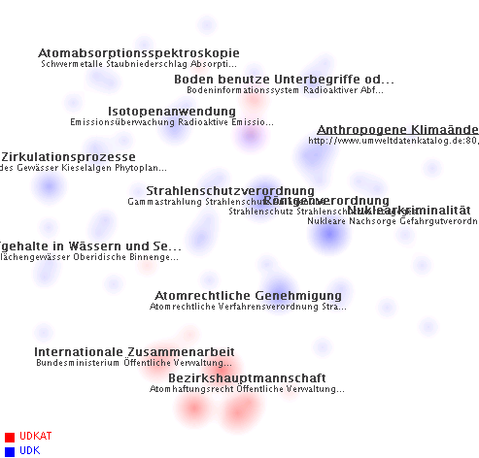
Resources exclusively from UDK Austria
Resources exclusively from UDK Germany
Resources which exist in UDK Austria and UDK Germany

Fig. 6: Comparing two Environmental information sources, UDK Germany and UDK Austria, for the Search Term "Atom*". Obviously the topical structure of both sources is very different.

Figure 6 displays the result of a query for term “Atom*” (all terms starting with Atom) executed against the Austrian (red coded) and the German (blue coded) version of UDK. Obviously both sources have very few topical concentrations in common, which is a valid observation matching reality: Austria, not having any nuclear power plants itself, is mainly concerned with civil protection and therefore querying for „atom“ reveals topics (bottom of figure 6) like „International Cooperation“ or “Bezirkshauptmanschaft“, an Austrian state administration unit which, among other tasks, deals with the protection of Austrians citizens. On the other hand, query topics from the German UDK cover many technical aspects such as atom absorption spectroscopy (top left corner), circulation processes (top left), by-laws for radiation protection (middle) and nuclear crime (middle right). Furthermore, Figure 6 clearly displays a split into a technical part (top-left) and a juristictial and administration part (middle-bottom right). Overlapping regions (middle-top) are related to ground and radioactive waste, issues clearly concerning both Austria and Germany.

Standard methods for comparing different information sources on the web depend on a predefined measurement like for example Precision and Recall (Oppenheim et al., 2000). This measure is used to compare query results on the same search term for different sources. Additionally more explorative data analysis methods like Hasse diagram techniques or POSAC methods (Glander-Höbl et.al. 2002) are used for performing graphical analysis on more than one search term.

Our approach differs from these scientific standard methods in two important points: The effort demanded of the user to perform an analysis of a query is comparably low and the topical structure of a query is taken into account. Since WebRat is based on the underlying similarity structure no measurement has to be defined for analyzing query differences, hence significantly reducing user interaction efforts. The underlying topic structure of a query is evaluated and arranged related to the topic structure of other information sources. This makes it easy for the user to analyze the underlying topic structures of each source and the relationship of topics between different sources, while keeping track of changes within queries and sources in a qualitative manner. Additionally search refinement is enhanced by choosing information sources covering topics the use is interested in.

It is not the intention to provide scientifically exact measures for similarity between data sources, or a quantitative measurement for differences. Instead, users are provided with a practical method for enhancing their search capabilities which demands a comparably low effort in interaction.

Discussion
Traditional text-based environmental search engines such as GEIN and UDK support a one-dimensional access strategy, only. As a result of a query, typical search engines overwhelm users with a often endless list of hits. The main disadvantage is the lack of context as the hits are just listed in a linear sequence. Such lists are often sorted by relevance, that is by the number of occurrences of the search term in the respective documents. In contrast, the concept of information landscapes combines traditional searching with innovative exploring. In the first step, WebRat’s query interface is traditional and allows user what they are used to: entering textual search terms. From then on, users start exploring the environmental information landscape. The metaphor of satellite images was chosen on purpose as satellite images and their use are commonly known in the environmental community. The multi-dimensional exploration features of WebRat are particularly of great advantage, if users have only a vague idea of what they are looking for and if they want to get an overview over a topic based on comparable few keywords entered in a textual form. Locating a clearly specified environmental information object is not the strength of WebRat: Standard environmental search engines are superior in this case because they allow for faster and more accurate identification of single items.
As described in the previous chapter our tool analyses existing data (e.g., metadata, abstract etc.) to build thematic clusters of the hits and, thus, provide context to the users which is another advantage compared to traditional environmental search engines. The context information is an added-value particularly for those users who are novices in a thematic field and who need guidance to get to know this field. Starting with a first overview at the highest level, users can either zoom into a more detailed level or they can refine their query. The refinement of the query brings them back to the traditional search engines. With this feature WebRat serves as mediating tool which offers new ways of the interaction between users and traditional search engines: As long as users need context information and orientation, they use the WebRat with its navigational support. As soon as they have a precise understanding of what they need, they make use of the search refinement feature. This feature brings the user directly to the traditional search engine which from now on is better suited to meet a user’s needs.
Thanks to the two-dimensional visualization of the search results it is also possible to display the results of different environmental information systems in different ways. This allows a direct comparison of the quality of the content of different environmental information systems. Such a comparison allows assessments on the relevance of environmental topics in different regions if the search engines are associated to such regions (as it is the case with the UDK Germany and UDK Austria).
Finally, WebRat works with whatever metadata and content snippets a search engine returns: This can lead to low quality results if few metadata or poor snippets are available, and there may even be no results at all if all repositories return empty result sets. Still, as environmental metadata is usually of high quality, particularly in the case of UDK, WebRat turns out to be an appropriate, easy to use tool for search and retrieval of environmental information objects.

Summary and Outlook
The underlying idea our approach is to provide users with as many guidance as possible without constraining them too much. The strength of WebRat is its capability to use not only metadata but also information content to find resources which match a given query. The multi-dimensional navigation features together with the labeling features and possibilities of query refinement provide new functionalities to environmental information systems which did not exist before.
In the near future, the WebRat will be extended by adding further repositories, the query results of which can be merged to extend the number of relevant documents found. Metadata will be integrated more tightly by weighting known metadata fields in comparison to general information as provided in content snippets. Finally, the clusters identified by the system will be arranged into a hierarchy representing a whole document repository (not just a search space).
Acknowledgement
The Know-Center is a Competence Center funded within the Austrian Competence Centers Programme K plus under the auspices of the Austrian Ministry of Transport, Innovation and Technology (www.kplus.at).
Bibliography
ADL (2000): Alexandria Digital Library. http://www.alexandria.ucsb.edu/
Chalmers M. (1993). Using a landscape metaphor to represent a corpus of documents. COSIT 93, pp. 337-390.
Dodge, M. (2002): An Atlas of Cyberspaces, http://www.cybergeography.org/atlas/atlas.html
Glander-Höbel C., Voigt K. and Welzl G., Comparing search engines with respect to environmental chemistry using statistical and mathematical evaluation methods, In Proceedings of Online Information 2001
Granitzer M., Kienreich, W., Sabol, V (2002): WebRat – Applications of a light-weight, web-based retrieval, clustering and visualisation framework. To be published in Proceedings of PAKM – 4th International Conference on Practical Aspects of Knowledge Management, LNCS Series, Springer, 2002.
Kraak, M.-J., Driel, R. (1997). Principles of Hypermaps, Computers and Geosciences, Vol. 24, No 4, 1997, pp. 457-464, http://www.itc.nl/~kraak/hypermap/Hypermaps.html
Larson, R. (1995). Geographic Information Retrieval and Spatial Browsing. University of California. http://sherlock.berkeley.edu/geo_ir/PART1.html.
Oppenheim C., Morris A.,McKnight C. and Lowley S.(2000), The evaluation of WWW search engines, progress in documentation, Journal of Documentation, 56(2) 190-211
Sabol, V. (2001). Visualisation Islands: Interactive Visualisation and Clustering of Search Result Sets, Master’s Thesis at IICM, Graz University of Technology.
Tochtermann, K., Maurer, H. (2000): Knowledge Management and Environmental Informatics. J.UCS, 6(4), Springer, May 2000, p. 517-536, http://www.jucs.org.
Tochtermann, K. (2002a): Environmental Informatics; Encyclopedia of Environmetrics, (eds. A. El-Shaarawi, W. Piegorsch), Bd. 2, S. 1047-1053, John Wiley & Sons.
Tochtermann, K. (2002b): Personalization in the context of digital libraries and knowledge management (in German), Habilitation Thesis at TU Graz.

Klaus Tochtermann, Vedran Sabol, Wolfgang Kienreich, Michael Granitzer, Jutta Becker; Know-Center, Inffeldgasse 16c, 8010 Graz (Austria). Email: {ktochter, vsabol, wkien, mgrani, jbecker}@know-center.at.

